Bahria University

**MID EXAM**

**Match Record System**

October 29, 2024

Name: Asim Ali | 01-131232-015

Class: BSE-3A

**DSA**

SIR. ALEEM AHMAD

**MID**

**Match Record System**

**Code:**

**[GitHub LINK](https://github.com/iasimkhan2005/Match-Record-System.git)**

**Menu:**

**Output Screenshots:**

1. **INSERT AT START**:

* First, we will **Insert 564** at Start and **Then 563**:

1. **INSERT AT END**:

* We will **Insert 570 At End.**

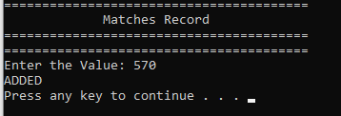

1. **Delete Score from Record**:

1. **Display Scores (In Sequence):**

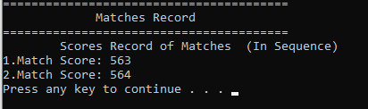

1. **Display Scores (In Reverse Order):**

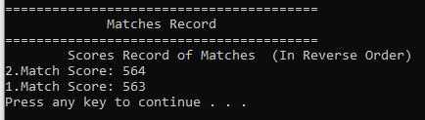

1. **Highest and Lowest Score in Record:**

* We Added Some more scores in the Record , so we can check the highest and Lowest Score , the following is the display of scores in the record:

